**ĐỀ ÔN 1**

**READING**

**I. Read and fill in the gaps:**

|  |
| --- |
| under on in |

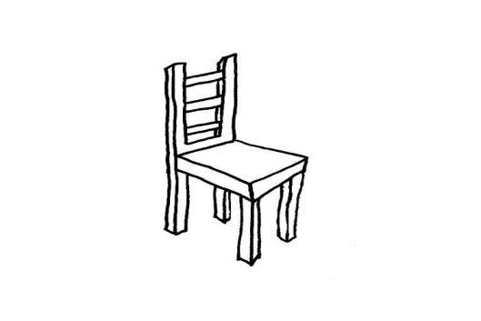

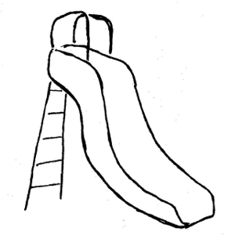

Vinh sister’s wants her teddy bear. Mom looks in the pool. Dad looks (1) ______ the chair. They can’t find it. Vinh looks (2) ______ the slide. There it is! They are happy!

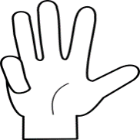**II. Look and read. Put a check (v) or a cross (x): ( 2pts)**

|  |
| --- |
|  |

1. four fingers

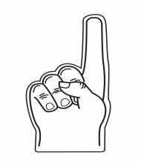

|  |
| --- |
|  |

1. two fingers

**III. Read and match**

1. What’s this? a. My name’s Rosy.

2. What’s your name? b. It’s a ball.

3. How old are you? c. I’m fine, thank you.

4. How are you? d. I’m ten.

**WRITING**

**I. Fill in the gap with a suitable word (2pts)**

|  |
| --- |
| sister dad mom |

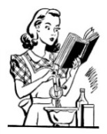

1. This is my ........................................___ .

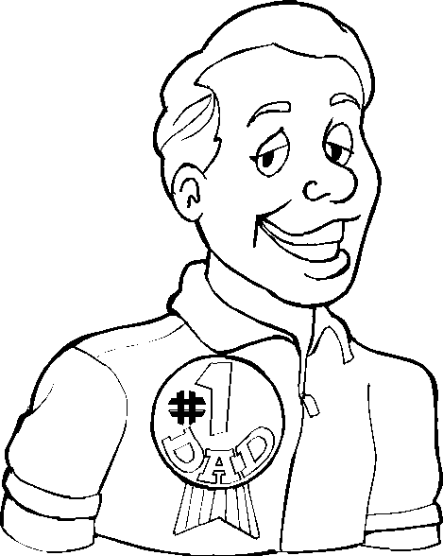

2. This is my .........................................____.

**II. Order the words: (4pts)**

1. slide. / It’s / the / under

_____________________________________________

1. your /teddy bear? / Where’s

_____________________________________________

**III. Write the words in the correct box: (4pts)**

|  |
| --- |
| pilot nose legs farmer |

|  |
| --- |
| Body  __________  **__________** |

|  |
| --- |
| Jobs  **__________**  **__________** |

**ĐỀ ÔN 2**

**READING**

1. **Look at the pictures carefully. Match the pictures with the sentences. (4pts)**

|  |  |  |  |  |
| --- | --- | --- | --- | --- |
| **A.** |  | Example:   1. This is a goal. | **B.** |  |
| **C.** |  | 2. Where is the bag?  It’s on the seesaw.  3. Is he a teacher?  Yes, he is. | **D.** |  |
| **E.** |  | 4. This is my grandpa.  5. The doll is in the bag. | **F.** |  |
| **G.** |  | 6. Is she a pilot?  No, she isn’t. She’s a doctor.  7. Where is the teddy bear?  It’s on the slide. | **H.** |  |
| **I.** |  | 8. He’s a firefighter.  9. It’s dad’s book. | **J.** |  |

**Example: 1. __C__ 2. ______ 3. ______ 4. ______ 5. ______**

**6. ______ 7. ______ 8. ______ 9. ______**

1. **Read this. Choose a word from the box. Write the correct word. (3pts)**



Hi! My name’s Alex. I’m (1) ______________. I’m in the park with my friends. Can you see the picture? I am in a (2) _______________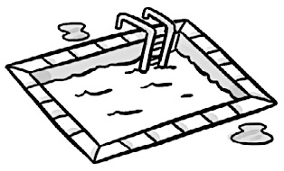. There is a kite on the (3) _______________. In the seesaw, there is a (4) _____________ 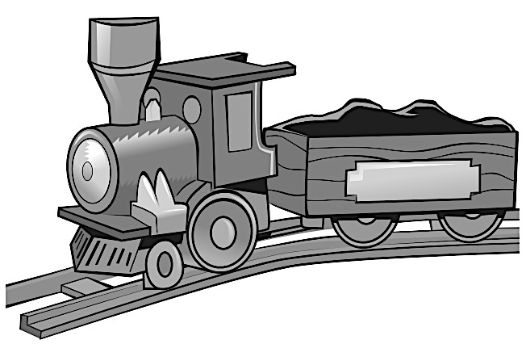.

My favorite toy is a (5) _________________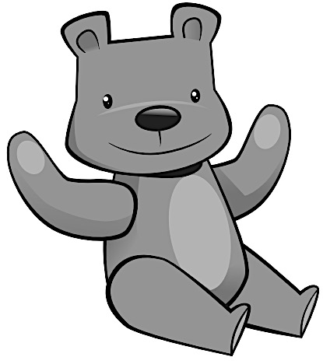. It’s in the bag. On the swing, there is a (6) ________________ 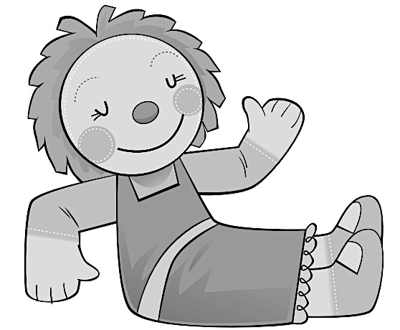. We like playing in the park.

|  |  |  |
| --- | --- | --- |
| pool | seven | slide |
| train | doll | teddy bear |

1. **Choose the best answer. (3pts)**

|  |  |  |  |
| --- | --- | --- | --- |
| 1. What’s this?   A. It’s an eraser.   1. It’s a bag. 2. It’s a car. |  | 1. Is it your teddy bear? 2. Yes, it is. 3. No, it isn’t. 4. No, It’s my car. |  |
| 1. What are these? 2. These are my faces. 3. These are my eyes. 4. These are my hands. |  | 1. Is he a firefighter? 2. Yes, he is. 3. No, he isn’t. 4. Yes, she is. |  |
| 1. Where is the frisbee? 2. It’s under the goal. 3. It’s on the goal. 4. It’s in the goal. |  | 1. What’s this? 2. It’s a seesaw. 3. It’s an ice cream. 4. It’s a face. |  |

**WRITING**

**I. Write the words. (4pts)**

|  |  |  |  |
| --- | --- | --- | --- |
| 1.  D – R – O – O | _______________ | A – F – C – E | _______________ |
| R – A – M | _______________ | 4.  R – A – C | _______________ |
| 5.  K – O – O – B | _______________ | 6.  L – O – T – P – I | _______________ |
| M – E – R – F – A – R | _______________ | 8.  B – E – K – I | _______________ |

**II. Look at the pictures and read the questions. Write one-word answers. (3pts)**

|  |  |  |  |
| --- | --- | --- | --- |
|  | What are these?  These are ___________ |  | What’s this?  It’s a ___________. |
|  | Where is the doll?  It’s _______ the seesaw. |  | What’s this?  It’s a ___________. |
|  | What’s this?  It’s _________ book. |  | Who’s she?  She’s a _________. |

**III. Answer about yourself. (3pts)**

|  |  |
| --- | --- |
| 1. What’s your name?   ___________________________________________ | |
| 1. How old are you? ___________________________________________ | |
| 1. How many people are there in your family?   ___________________________________________ | |
| 1. Are you a teacher?   ___________________________________________ | |
| 1. What’s your favorite toy?   ___________________________________________ | |
| 1. What’s your favorite color?   ___________________________________________ |